MediCare
Clinic Management & Appointment System
Problem Statement, Use Case Diagram and Requirements

1. Problem Statement and Objectives

1.1 Problem Statement
Clinics that still book by phone, paper or messaging apps run into the same set of problems. Patients wait for slots and have no way of seeing what is free. Doctors cannot easily keep a clean schedule, and double bookings slip through. Medical history lives in scattered files or in people's heads, so a doctor often starts a visit without the full picture. Management has no simple way to see how the clinic is doing. In particular:
- Traditional booking methods are slow and inefficient.
- There is no centralized digital record of patients' medical history.
- Doctors struggle to manage their schedules and avoid conflicting appointments.
- Patients receive no automated appointment reminders.
- Management has limited visibility into clinic operations and patient trends.

1.2 Objectives
Main goal: build MediCare, a web-based clinic platform where patients book and manage appointments online, doctors run their schedules and patient records, and administrators oversee the whole clinic.
Specific objectives:
# | Objective | Addresses
1 | Let patients find an approved doctor by specialization, location and availability, and book, cancel or reschedule online without double bookings | Slow booking, schedule conflicts
2 | Keep one secure digital record per patient: visit records, test uploads and prescriptions, available to the patient and their own doctor | No central medical history
3 | Give doctors a dashboard for working hours, vacations, appointment requests and quick patient information | Schedule management
4 | Send instant (SignalR) notifications, plus SMS (Twilio) and email (SendGrid) reminders 24 hours before appointments | No reminders
5 | Give administrators doctor approval, patient and specialization management, and charts and reports on appointments, popular doctors and revenue | Limited visibility
6 | Build it reliably and securely with N-Tier architecture, the Repository and Unit of Work patterns, dependency injection and ASP.NET Identity roles, and deploy it live on Azure | Quality and maintainability

2. Use Case Diagram
The diagram shows what each actor can do in MediCare. The Patient (10 use cases), Doctor (10) and Admin (8) are the main actors, and Twilio / SendGrid is the external service that delivers SMS and email reminders. The box at the bottom lists the business rules that apply across all use cases.
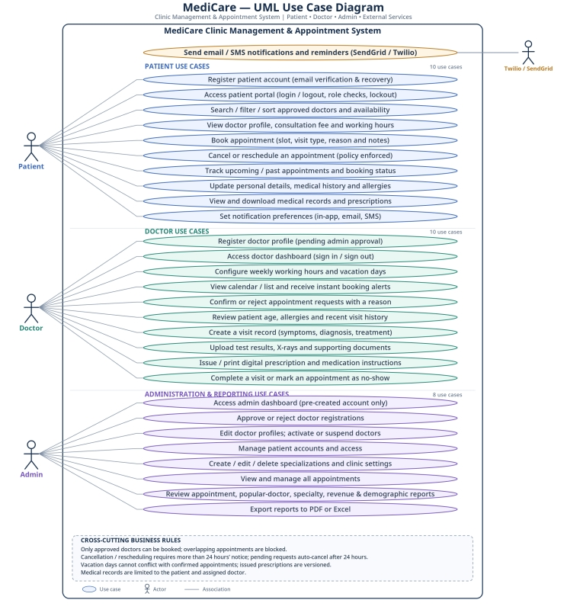
Figure 1. MediCare UML use case diagram.

3. Functional and Non-Functional Requirements

3.1 Functional Requirements
What the system has to be able to do, grouped by area. Priorities: Must = needed for the first version, Should = added right after if time allows, Could = nice to have.

3.1.1 Accounts and Login
Requirement | Priority
Patients can register with name, email, phone, password, date of birth and gender. The form validates everything. | Must
Doctors register with their details plus specialization, license number, fee and photo. The account stays Pending until an admin approves it. | Must
The admin account is created by us (seeded). Nobody can sign up as admin. | Must
Login / logout, with pages restricted by role (Patient, Doctor, Admin). | Must
Email confirmation and password reset by email. | Should
Temporary lockout after a few failed logins in a row. | Should

3.1.2 Finding a Doctor
Requirement | Priority
Show only approved doctors, with paging. | Must
Search by name and filter by specialization, location and availability (today / this week). | Must
Doctor page with photo, specialization, fee and working hours. | Must
Sort by fee or by earliest available time. | Could

3.1.3 Booking Appointments
Requirement | Priority
Show available slots in a FullCalendar.js calendar based on the doctor's schedule. | Must
Book by picking a date and time from the free slots. | Must
Block double bookings, even if two people try to book the exact same slot at the same time. | Must
Patients can cancel (as long as they follow the rules). | Must
Patients can reschedule to another free slot. | Must
Appointment statuses: Pending, Confirmed, Rejected, Cancelled, Completed, No-show. | Must
Different appointment types (new visit, follow-up, check-up) created with the Factory Pattern. | Should
Reason for the visit and optional notes when booking. | Should

3.1.4 Doctor Dashboard
Requirement | Priority
Today's and this week's appointments in both calendar and list views. | Must
Set working hours (days, from/to, slot length). | Must
Set vacation days. | Must
Confirm or reject requests, and give a reason when rejecting. | Must
Quick view of a patient's age, allergies and recent visits. | Must

3.1.5 Notifications
Requirement | Priority
Instant SignalR notification to the doctor when a new appointment is booked. | Must
Instant SignalR notification to the patient when an appointment is confirmed or rejected. | Must
In-app reminder before the appointment. | Should
SMS reminder through Twilio. | Should
Email (SendGrid) for confirmations, cancellations and reminders. | Should
Automatic reminder 24 hours before (background service). | Should
Patients can choose their channels (SMS, email, in-app) or turn them off. | Should
Notification types created with the Factory Pattern. | Should

3.1.6 Medical Records and Prescriptions
Requirement | Priority
Doctor creates a medical record for each visit. | Must
Record symptoms, diagnosis and treatment notes. | Must
Upload test results, X-rays and documents (PDF, JPG, PNG). | Should
View a patient's full medical history. | Must
Digital prescription linked to the medical record. | Must
Medication list with name, dose, frequency, duration and instructions. | Must
Print-friendly prescription. | Should
Prescription history for the patient. | Must

3.1.7 Patient Profile
Requirement | Priority
See upcoming and past appointments. | Must
See their own records and prescriptions. | Must
Update personal info, medical history and allergies. | Must
Download medical documents. | Should

3.1.8 Admin Dashboard and Reports
Requirement | Priority
Approve or reject doctor registrations. | Must
Edit doctor profiles and activate / suspend doctors. | Must
Manage patients and their access. | Must
Add, edit and delete specializations. | Must
Clinic settings (name, default slot length, cancellation policy). | Should
See and manage all appointments. | Must
Chart.js monthly appointment statistics. | Should
Most popular doctors and specializations. | Should
Revenue reports and financial summaries. | Should
Patient demographics and trends. | Could
Export reports to PDF or Excel. | Could

3.2 Non-Functional Requirements
These describe how well the system needs to work. The numbers are our own targets (assumptions) and will be confirmed later if possible.
Quality | What we are aiming for
Security | HTTPS everywhere. Passwords hashed with ASP.NET Identity. Anti-forgery tokens on forms. Server-side validation. EF Core parameterized queries. Secrets in Azure Key Vault or app settings, never hardcoded.
Access control | Trying to open a page outside your role returns 403.
Privacy | Medical data is only visible to the patient and their own doctor. Every time a record is opened or changed, we log it.
Performance | 95% of pages under 3 seconds with about 100 concurrent users. Search under 2 seconds. Real-time notifications under 2 seconds.
Ease of use | Booking in 4 steps or fewer from the doctor's page. Clear error messages. Simple navigation.
Accessibility | Aim for WCAG 2.1 AA where it is realistic for us.
Reliability | Around 99.5% uptime on Azure. Daily Azure SQL backups. Retry failed SMS and emails.
Data integrity | Related changes saved in one transaction (Unit of Work). RowVersion to stop two people grabbing the same slot.
Scalability | Separate layers, stateless app, Azure SignalR Service.
Maintainability | Clean separation of Web / Services / Data. Dependency injection. At least 70% unit test coverage on the services (we will try).
Compatibility | Latest Chrome, Edge, Firefox, Safari. Phones from about 360px wide.
Deployment | CI/CD with GitHub Actions or Azure DevOps. At least Staging and Production environments.
Time zones | Store everything in UTC, show it in Cairo time.
Compliance | Follow personal and health data rules and get user consent where needed.

